LoRa Faceted Device Assisting Women’s Safety

|  |  |  |
| --- | --- | --- |
|  |  |  |
| Suresh Kumar R  *Center for System Design*  *Chennai Institute of Technology*  Chennai, India  sureshkumarr@citchennai.net    Vijayaraj A  *Dept. of Information Technology*  *Vignan's Foundation for Science,*  *Technology & Research*  Andhra Pradesh, India | Ayyadurai M  *Department of ECE*  *SRM Institute of Science and*  *Technology*  Chennai, India ayyaduraiece@gmail.com  Dhanagopal R  *Center for System Design*  *Chennai Institute of Technology,*  Chennai, India dhanagopalr@citchennai.net | Vasanth Raj PT  *Center for System Design*  *Chennai Institute of Technology*  Chennai, India vasanth14191@gmail.com |

dravr_it@vignan.ac.in

***Abstract*—Today's situation, the necessary examination of every young girl's mind, taking into account the constant increase in issues of women's uprising in the past, is her safety. To help settle this issue we propose a LoRa based women wellbeing system. This gadget comprises of a framework that guarantees double cautions if she thinks she is in a difficult situation. This framework can be turned on by a lady on the off chance that she even figures she would be in a difficult situation. In a panic alarming framework, if the lady is hit on the head from behind, she may never find an opportunity to press the emergency signal and nobody will realize she is in a difficult situation. Our framework tackles this issue. This gadget is to be turned on ahead of time by a lady in the event that she is strolling on a forlorn street or some dull rear entryway or any far off territory. Just the lady validated to the gadgets can begin the framework by finger impression check. When begun the gadgets requires the lady to continually check her finger on the framework like clockwork, else the framework presently sends her area to the approved number through SMS. In this case regardless of whether somebody hits the lady or the lady tumbles down and get oblivious, she doesn't have to do anything, the framework consequently sends message when the fingerprint is missed. The gadget utilizes GPS sensor alongside a GS, modem, LCD display, LoRa and microcontroller based circuit to accomplish this framework.**

***Keywords— LoRa, GPS, GSM, Arduino***

# I. INTRODUCTION

|  |
| --- |
| 978-1-6654-8094-9/22/$31.00 ©2022 IEEE |

Protection is a state of protection from danger and harm. In a general sense, security is closer to a concept like security. Another emphasis is on protecting the nuances between the two from outward danger. Anyone or act that breaks into the condition of safety is liable for a security breach. In most cases, "security" is inseparable from "goodness", but the special word "security" indicates that something is not yet particularly secures, designed with ATmega328 for this project. This device provides women's security Systems using GPS, GSM, LORA. Devices include GPS receivers, microprocessors, and GSM modems. GPS receivers must be placed from satellites within latitude and longitude to receive information. The microcomputer measures the data and sends this controlled data. The GSM modem interferes with the MCU for clients using the GSM modem. GSM modems send SMS to predefined versatile numbers. If a woman is at risk and needs self-defense, powering on the device will immediately activate the entire system and send location information via GSM and GPS via LoRa. An SMS will be sent to that person. This system gets an Arduino Mega (ATmega2560) Control system that functions as the brain of the system because all program instructions are stored in the system. Here is a fingerprint sensor to know about the authentication of authorized people. If a woman has any emergency every 5 minutes, the fingerprint sensor will require a beating print of the authorized person and a warning message will be sent to the parties concerned. All data transferred via LORA and monitored in the LORA receiver section.

## II. LITERATURE SURVEY

Bhuvaneshwari Mehtre [1] proposed “A Raspberry Pibased Safety System for Women Security using IOT”. In this system, they are using three ways of connecting to the concerned authorities. S. Bhuvaneswari, Akhila Krishna.D, Annapoorna. M, Gayathri. G [2] proposed that, Defense at

Touch – A Sensor Based Hand-Held Device for Women Safety. The system provides a mechanism for the woman to respond immediately when she is in danger. Juhitha et al [3] designed and implemented the Women Safety System Using Mobile Application in Real-Time Environment. They are creating mobile application. This application requires an underlying enrollment alongside Emergency contacts. Sanjana Babdi et al [4] proposed that, “Women’s Safety Using IOT”. This system describes Arduino Nano and a safe and secure electronic system for women, including sensors such as pulse rate sensors, accelerometers and temperature sensors. The project also uses buzzers, GSM and GPS. Sathyasri et al [5] implemented, “Design and Implementation of Women Safety System Based on IOT Technology”. This system uses a microcontroller (ATmega2560), a buzzer, a nerve simulator, a vibration sensor, a GPS module (Neo6M), an IOT module (ESP-12E), a trigger and GSM module (SIM900). This system requires the device to remain triggered when a woman feels dangerous. Preethu Daniel et al [6] proposed that, “Smart Band for Women Safety”. In this system, they are using GSM, URL, Arduino, SIM800L. In this project, they have made an attempt to develop a smart device that can assist women when they feel unsecure. This device is a wearable band that women can wear. Dudyala Sunitha et al [7] tells that, “Design and Implementation of Women Safety System Based on IOT Technologies”. In this system, they are using Mobile application, GPS Arduino, MATLAB based buzzer, camera and button to activate the services. This gadget is incredibly versatile and can be initiated by the casualty on being attacked just by the snap of a catch that will bring her present area and also capture the image of the attacker via MATLAB based camera. Wasim Akram et al [8] proposed that, “Design of a Smart Safety Device for Women using IoT”. The proposed work aims at designing IOT based safety device that relies on providing security to women by fingerprint-based method of connectivity to the device and alerting nearby people and police when a women is not safe. Manasa et al [9] says “Smart Security Device for Women Safety”. This project uses GSM and GPS modems. The system is interconnected with an alarm system to alert police stations and relatives. This detection and messaging system consists of Arduino board, a GSM modem and a GPS receiver. Jismi Thomas et al [10] proposed that “Touch Me Not-A Women Safety Device”. In this system, they are using Arduino programming, GSM module, GPS Module, SD Module. In this device, Button can be attached to the cloth. Imtiaz Hanif et al [11] tell that, “An IOT based Device for Women’s SelfSecurity System to Avoid Unlawful Activities”. In this article [12], we have developed an IoT-based embedded device that can communicate with on-demand emergency calls.

# III. EXISTING METHOD

The mobile apps contain all the important functions such as GPS tracking, emergency contact numbers, instructions on safe places, etc. The app also corrects the safe areas and their safety values that are available at the time of a problem. It also allows users to identify unsafe areas and help others. A panic button sends a radio signal when pressed and alerts you in an emergency. Wearable devices are used to keep track of information in real time. They have motion sensors that take the snapshot and synchronize it with mobile devices. The bell system is also used in an emergency and alerts the authorized person.

## IV. PROPOSED SYSTEM

In this framework, we use ARDUINO which goes about as mind of the framework, on the grounds that the whole framework program is guidance put away in it. Here we have fingerprint sensor to know about authentication of the authorized person. If women have some emergency situation every five minutes fingerprint sensor needs thump print of the authorized person and alert message will send to the concern person. All the data is transferred through LORA and monitored at LORA receiver section. The block diagram of the transmitter is shown in figure 1 and the monitoring system shown in figure 2.

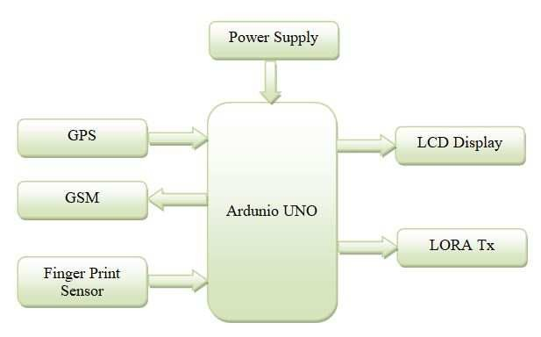

Fig. 1. Block diagram of the Transmitter

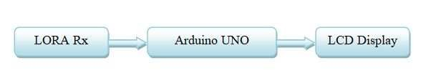

Fig. 2. Monitoring Section

List of Modules:

The lists of modules required for the device are,

1. Arduino Uno
2. GPS
3. LCD DISPLAY
4. GSM
5. Fingerprint Sensor
6. LoRa
7. *Arduino Uno:*

Arduino Uno is a microcontroller board that supports ATmega328P. It has 6 analog inputs, a 16 MHz crystal oscillator, a USB port,14 digital input/output pins, punch sockets, connections, ICSP connectors and push buttons, including everything who wants to help a microcontroller; just Connect it to PC via USB connection, or force it to start with an DC/AC connection or battery.

1. *GPS:*

Global Positioning System (GPS) can be a satellite navigation system that provides the user with the overall location and time information of weather conditions. GPS satellites orbit the earth exactly twice a day. Each satellite transmits specific signals and specific orbiting boundaries so that GPS devices can interpret and process the exact area of the satellite. The GPS device uses this data and conversations to find the customer’s area of attention. Basically, a GPS receiver estimates the position of each satellite based on how long it takes to receive a communication signal. By measuring the distance over satellites, the receiver can determine the user's location and display it electronically. Stay on the road, pull a golf course, live at home, or explore all.

1. *LCD Display:*

The 16x2 LCD means it can show 16 characters per line so there are 2 lines. Each character of this LCD is displayed on a 5x7 pixel screen. This LCD has 2 registers, in particular, data and command. The command record stores its instructions provided on the LCD. The command is a guide provided by the LCD to perform pre-specified tasks such as starting it, display control, setting the directional position, display control, clearing its screen as well as the data log stores the information displayed on the LCD screen. The data is ASCII evaluation of the features displayed on the LCD.

1. *GSM:*

Limited and networks integration in detail explained aesthetics GSM, but the devices do not cause the hardware. It should be restricted to one senses only the least understandable once, so log make operational managers to buy equipment from various service providers. GSM networks are divided into three main modes: interconnection structure (SS), base structure (BSS), and performance and emotional support network (OSS). The GSM model is used to build documents between the PC and the GSM-G/PRS model. (GSM) Global Mobile Communication System SIM Card is inserted inside the mobile phone to send and receive GPRS messages to the victim. The global Mobile

Communication System SIM card number included in the format. With the expansion of GSM usage, the benefit class scale has produced a much broader discourse that includes some of the most common applications, machine tools, and machine-to-machine exchanges. It operates at a frequency of 900MHz -1800MHz.

1. *Sensor:*

The R305 fingerprint module includes a unique visual effects sensor, high-speed DSP processor, fingerprint scanner optimization, advanced FLASH and other tools and programming and programming, stable execution, vertical mode, fingerprint viewing, image preparation, fingerprint viewer, search and save storage and other work. Fingerprinting involves two components: the fingerprint image object and the fingerprint coordinator (the coordinator can be 1: 1 or 1: N). When writing, the client needs to fingerprint several times. The technique will capture two images of the cross finger, depending on the result prepared and the format storage.

1. *LoRa:*

LORA (Long Range) is a balanced strategy for a large network with low power consumption. This is due to the diffusion classification methods derived from CSS. Lora uses unlicensed sub-GHz frequency bands such as 433 MHz, 865 to 867 MHz (India), 868MHz (Europe), 915 MHz (Australia and North America), and 923 MHz (Asia) Consume less electricity. The technology covers the body but other technologies and protocols like the LoRa WAN cover upper layer. Depending on the spreading factor, data rates between 0.3 kbit/s and 27 kbit/s can be achieved. The LoRa device uses geographic functions to subdivide device locations through door-to-door clocks.

## V. RESULTAND DISCUSSION

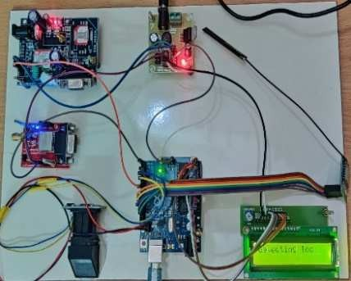

Fig. 3. Transmitter working model

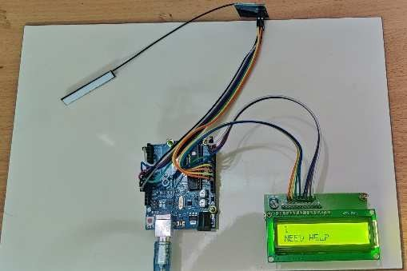

Fig. 4.Working model of the supervisory department

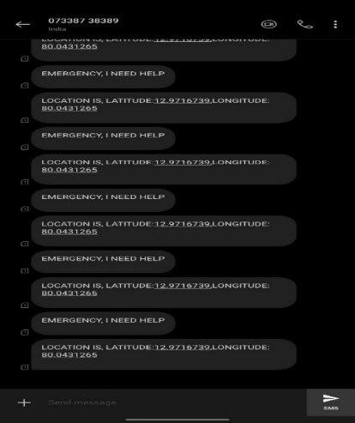

Fig. 5. Output Message

As explained in previous section, we use the ARDUINO for this system, which works as a system memory, as all program instructions are stored there. Here we have fingerprints to determine the authenticity of the authorized person. If women have an emergency situation every five minutes, the fingerprint sensor must send a blueprint of the authorized person and an alert is sent to the person concerned. All data is transmitted via LORA and monitored in the LORA receiver area. The above working model represents the transmitter in the source part and the monitoring area at the receiver. The output is received as a message to the authorized person after the system has started. The working model of the transmitter and supervisory department is shown in figure 3 and 4. And the output message is indicated in figure 5.

## VI. CONCLUSION

The main objective of our project is to ensure the safety and security of all women in our society. According to a survey in India, 53% women who are working does not feel safe during night shifts (Chennai-2%, Mumbai 2%, Hyderabad 35%, Bangalore 56%) Of the total 86% working women in Delhi, Pune, Kolkata, Hyderabad and Mumbai have higher odds of women facing hurdles than elsewhere.

Our effort behind this project is to create a model that provides the benefits of a personal protection system. This design will affect most of the key issues facing women and can help to save them. Existing systems provide ways to push the panic button but no other options are suggested. Our concept is used to look at the victim's location in terms of latitude and longitude which can be further tracked using Google Maps and disseminated information over long distances. This system helps to reduce the status of women. In the current situation, women's safety is paramount. These crimes are usually eliminated through real-time implementation of the proposed system.

# REFERENCES

1. Bhuvaneshwari Mehtre, (2020) “A Raspberry Pi-based Safety System for Women Security using IoT”, International Journal of Science and Research (IJSR).
2. S. Bhuvaneswari, D. Akhila Krishna, M. Annapoorna, G. Gayathri,

(2020) “Defense at Touch – A Sensor Based Hand-Held Device for Women Safety”, International Journal of Future Generation Communication and Networking.

1. S. Juhitha, M. Pavithra, E. Archana, (2020) “Design and Implementation of Women Safety System Using Mobile Application in Real-Time Environment”, International Journal of Research in Engineering, Science and Management.
2. Sanjana Babdi, Janhavi Jathar, Tejaswini Tambe, Prof. Simran Singhan, (2020) “WOMEN’S SAFETY USING IOT”, International Research Journal of Engineering and Technology (IRJET).
3. B. Sathyasri, U. JaishreeVidhya, G. V. K. JothiSree, T. Pratheeba, K.

Ragapriya , (2019) “Design and Implementation of Women Safety System Based on IoT Technology”, International Journal of Recent Technology and Engineering (IJRTE).

1. Preethu Daniel, Anciya Backer, Shini K.N, Sulthana Nazar, (2019) “Smart Band for Women Safety”, nternational Journal of Computer Science Trends and Technology (IJCST).
2. Dudyala Sunitha, Ms. Udayini Chandana, (2019) “Design and

Implementation of Women Safety System Based on IoT

Technologies”, Journal of engineering science.

1. Wasim Akram, Mohit Jain, C. Sweetlin Hamalatha, (2019) “Design of a Smart Safety Device for Women using IoT”, International conference on recent trends in advanced computing 2019.
2. Manasa K.C, Subba Lakshmi SV, Sneha G, Sowmya SM, Shilpa shreeyadav GC, (2018) “Smart Security Device for Women Safety”, International Journal of Latest Technology in Engineering, Management & Applied Science (IJLTEMAS).
3. Jismi Thomas, Maneesha K J, Nambissan Shruthi Vijayan, Prof. Divya

R, (2018) “TOUCH ME NOT-A Women Safety Device”, International Research Journal of Engineering and Technology (IRJET).

1. Md. Imtiaz Hanif, Shakil Ahmed, Wahiduzzaman Akanda, Shohag Barman, (2020) “An IoT based Device for Women’s Self-Security System to Avoid Unlawful Activities”, (IJACSA) International Journal of Advanced Computer Science and Applications.
2. Garima Tiwari, Adarsh Tiwari, Amit Kumar, Himanshu Verma, Kalyan Krishna Awasthi, (2020 ) “ ‘Kavach’ - Women Safety Device with GPS Tracking and SMS Alert”, Journal of Emerging

Technologies and Innovative Research.

Appendix B

**Appendix A**